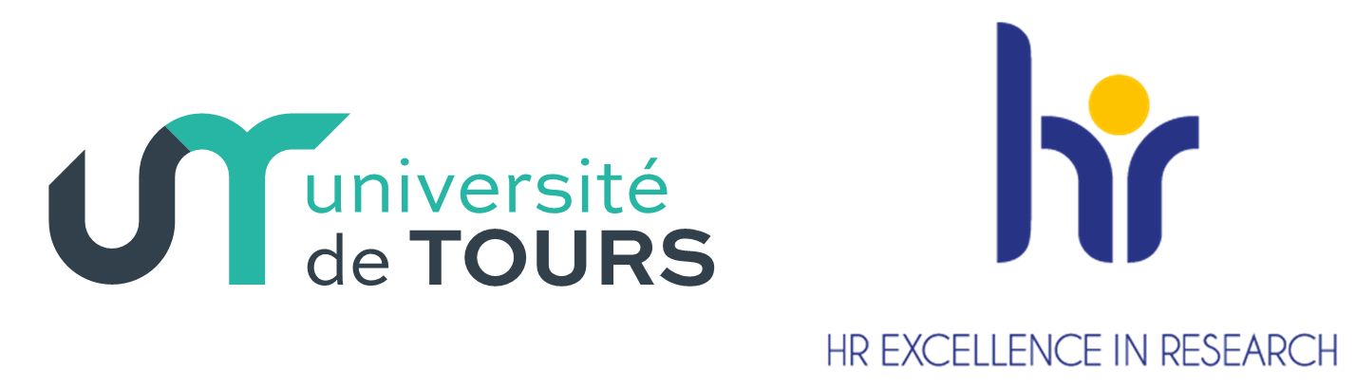

Mentoring for Junior Faculty members
Workshop held on the 23rd of January 2023, University of Tours
Organized by Prof. J. Casas, HRS4R leader

Context : Junior faculty face specific and complex problems in the first years of their installment. In-house statistics show a worrisome decline of the use of easy-to-get small grants for reducing their teaching loads, grants proposed by our institution for advancing their research agenda. In a context of joint increased competition for professor positions and continuing reduction of such positions, this trend might signal the abandon of ambitious career plans among our most promising faculty and a sliding of the research output by our university. The corollary question of this observation is the current lack of a program – here and in most if not all French universities- to help these junior faculty members to make their transition from post-docs to full fledged PIs. Our HRS4R plan approved by the EU aims at redressing this through mentorships among faculty, but the contours and scope of this action remains to be set. After hearing three internationally recognized heads of such structures, we will open the floor for any further input the HRS4R committee can use in the coming year.

14h15 : Dr. Kay GUCCIONE, Head of Research Culture & Researcher Development at the University of Glasgow (Scotland)
The Far-reaching Impacts of Mentoring Junior Faculty. Mentoring is an important instrument for enabling novices in any field to develop specialist expertise. It has been shown to assist faculty to evaluate their position and to plan for success in an increasingly competitive academic job market. Mentoring provides an opportunity for new lecturers to make interpersonal connections, enabling informed and supportive professional development, and can enhance the development and profile of underrepresented. Mentoring can redress organizational norms and develop new cross-cultural models of academic success, embracing diverse approaches and populations. Both mentoring and the closely related discipline of coaching offer positive effects for early career researchers, increasing self-awareness and sensemaking decreasing perfectionism and increasing writing productivity and thesis completion, and decreasing thoughts of dropping out of the higher degree. This presentation will take a summary look at the outcomes of two mentoring programmes – Thesis Mentoring (PhD students mentored by postdocs), and Catalyst Mentoring (postdocs mentored by senior faculty) – documenting the positive outcomes for all participants, mentors, and mentees. By enhancing an organisations capacity for mentoring best practice through the structures and processes of formal mentoring programmes we can also create several broader impacts: on the mentors’ approach to research leadership, and on institution-wide approaches to developing researchers and research capability. This presentation will argue for an approach to researcher development that consolidates and centres the mentoring skill set.

Hidden Curriculum in Doctoral Education blog and book series, Supervising PhDs blog
Guccione, K., & Hutchinson, S. (2021). Coaching and Mentoring for Academic Development. Emerald Group Publishing.

14h45 : Prof. Geneviève LAMEUL, Directrice du CREAD-Rennes2 (centre de recherche éducation apprentissage didactique)
G. Lameul témoignera de la manière dont elle prend appui sur ses travaux de recherche (Lameul, 2016, 2023 à paraître) en sciences de l’éducation et de la formation pour guider ses activités en matière de « mentorat des jeunes membres du corps enseignant ». Elle rappellera dans un premier temps, les huit conditions propices au développement professionnel et à la construction d’une posture d’expertise que dégagent ses travaux. Elle témoignera ensuite de la manière dont elle veille dans sa pratique et dans son institution (université Rennes2) à les faire vivre au quotidien dans la formation des nouveaux maîtres de conférence et dans l’accompagnement des doctorants au sein de son unité de recherche en relation avec l’école doctorale.

Ménard,L., Hoffmann, C. et Lameul, G. (2017) « Effets de la formation à l’enseignement sur les pratiques des nouveaux enseignants-chercheurs », Recherche et formation, 84 | 2017, 125-140.
Lameul, G., Daele, A. & Charlier, B. (2016). Accompagner l’innovation pédagogique. A., Daele, & E., Sylvestre, Le conseil pédagogique dans l’enseignement supérieur – Cadres de référence, outils d’analyse et de développement, ⟨De Boeck⟩. ⟨hal-01697183⟩
Lameul, G. (2016). Le développement professionnel des enseignants-chercheurs : entre recherche et enseignement, l'élaboration d'une posture d'expertise. (HDR) Education. Université Rennes 2 Haute Bretagne; CREAD.
Lameul, G. (2023, à paraître). Posture professionnelle et niche écologique : des constructions mutuelles et réciproques ? In Guérin, G., Simonian, S. et Thievenaz, J. (coord.), Activité et environnements de formation. Une approche écologique Prémisses d’une théorie, Octarès

15h15 : Dr. Manuela SCHICKA, coordinatrice of the Réseau romand de mentoring pour femmes and the workshop program REGARD, office for equality, diversity and inclusion, University of Fribourg (Switzerland)
The Réseau romand de mentoring pour femmes aims at supporting women in academia. The program offers a one-to-one mentoring for our mentees and workshops on career development topics. We also finance individual coachings for our mentees. The program is open to women at the end of their Ph.D. and postdocs who show a motivation for an academic career. Program duration of each edition is 18 months with 25 mentees. The first edition started in 2001 and till today about 300 mentees participated in the program. About one quarter of them obtained a professorship position meanwhile.
https://www.unifr.ch/f-mentoring/fr/

